Knaphill Methodist Church
“Let us pray”

A Prayer Diary for
September 2021

“Save your people …
Care for them; carry them
like a Good Shepherd.”Psalm 28:9 a,c,d TM

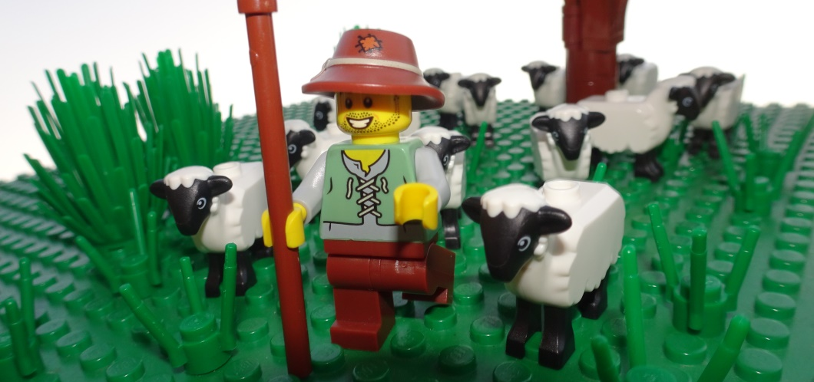

The Bible Society is creating a community garden, themed on Psalm 23, for RHS Chelsea, between 21 & 26 September 2021. It is designed by Sarah Eberle to ‘engage people’s emotions’, to allow ‘God’s word to be experienced with all our senses,’ & to change the conversation about the Bible in society’. After the show, the garden will find a new home at Winchester Hospice in Hampshire, opening later this year.
This month’s Prayer Diary is inspired by themes from Psalm 23.
Day/  Date | Theme/  Event | Pray for … |  | Notes  Thoughts  Action
“God, my Shepherd!” Psalm 23:1a TM
1st  Wednesday | The Good Shepherd | Reflect on what it means to have God as your Shepherd: how does the image work for you? It’s all about the relationship between Shepherd & sheep…
2nd  Thursday | Rev George Quarm | - … George’s welcome service today, as he takes ‘pastoral charge’ at Merrow, Stoughton & West Horsley: for him to know & feel God’s hand on his ministry; for new friendships & mission together.
3rd  Friday | Our Minister | - … Dave: that he will look after & take care of his KMC ‘flock’ – ‘bringing back’, & ‘strengthening’.
“I don’t need a thing.” Psalm 23:1b TM
4th  Saturday | ‘Jehovah Jireh … | - … my Provider, His grace is sufficient for me … My God shall supply all my needs according to His riches in glory; He cares for me.’ (SoF 1 284 Ref. Genesis 22:14) Pray these song words over your life.
5th  Sunday | Thanks-giving | ‘Count your blessings, name them, one by one …’ And then ‘Give thanks, with a grateful heart …’
“You have bedded me down in lush meadows,” Psalm 23:2a TM
6th  Monday | The ‘Busy’ | - … those who have not been able to ‘take a break’ over the summer: opportunities for rest & refreshment; renewal; inspiration to keep working.
7th  Tuesday | Haiti –following earth-quake | - … shelter, food & water to reach those still in need: medical support for the injured; comfort for the bereaved; safety of aid & rescue workers from armed gangs; more stability for the country’s future.
“… you find me quiet pools to drink from.” Psalm 23:2b TM
8th  Wednesday | Water Aid | - … the successful work of those providing clean water & good sanitation to those communities in need: for funding; for cooperation; for good health.
9th  Thursday | Preachers &Leaders  of Worship | - … the renewed inspiration & empowered spirits of all those who preach the Gospel & lead worship in fresh, relevant, ‘connective’ & enabling ways.
“True to your word, you let me catch my breath …” Psalm 23:3a TM
10th  Friday | God’s Word in Scripture | Make time to read God’s word for yourself: read it aloud; let it dwell within you; let it speak into your life. Pray for its inspiration to ‘give you breath’.
11th  Saturday | The ‘Breath-less’ | - … someone you know who needs to feel God’s breath upon them at this time: for knowledge of His presence; for peace; for reassurance; for hope.
“… and send me in the right direction.” Psalm 23:3b TM
12th  Sunday | KMC Covenant Service | - … KMC members to wholeheartedly rededicate themselves to God’s service, & to understand, & fulfil, what that means for the direction of their lives.
13th  Monday | KMC Vision | - … a clear revelation of God’s plans for KMC: for those in any authority to hear His voice, discern His will & have the courage & faith to act upon it.
“Even when the way goes through Death Valley …” Psalm 23:4a TM
14th  Tuesday | Afghans in Afgh-anistan | - … all those in ‘hiding’ from the Taliban: for safe shelter & resources; for strength & courage; for ‘good’ friends; for safe passage & successful escape.
15th  Wednesday | Covid-19 sufferers | - … those sick, in hospital, or on ventilation due to Covid-19: for timely medical interventions; for physical strength; for healing; for restoration.
“… I will not be afraid when you walk at my side.” Psalm 23:4b TM
16th  Thursday | Refugees | - … all those literally ‘running for their lives’: for their protection; for the compassion & action of those in positions to help; for safe refuge & a ‘home’
17th  Friday | The  ‘recently diag-nosed’ | - … anyone you know of who has had a ‘far-reaching’ medical diagnosis: for clarity of understand –ing; for compassionate care; for the best treatment for support from, & for, family & friends; for peace.
“Your trusty shepherd’s crook makes me feel secure.” Psalm 23:4c TM
18th  Saturday | Security person-nel | - … those whose job involves putting their lives on the line to keep others safe: for vigilance: for discipline; for good judgements; for their own safety
19th  Sunday | Christian ‘Security’ | Reflect on what this verse really means for you:  “The message of the cross is foolishness to those who are headed for destruction! But we who are being saved know it is the very power of God.”  1 Corinthians 1:18 NLT
“You serve me a six-course dinner right in front of my enemies.” Psalm 23:5a TM
20th  Monday | ‘Grace’ | Do you thank God for all you eat? At every meal?  Make an effort to ‘give thanks’ before you ‘break bread’ - pray for those without sufficient food today.
21st  Tuesday | Afghans in the UK | - … those resettling here: for suitable homes, school & work; for acceptance into communities; for help with language, ‘systems’, culture & trauma.
“You revive my drooping head;” Psalm 23:5b TM
22nd  Wednesday | The ‘Low’ | - … anyone you know who is ‘down’ at present: lift them up before God, by name; ask that they may feel His love around them. How can YOU bring joy & support into their life & situation? Then do it!
23rd  Thursday | En-courage! | “Therefore encourage one another and build each other up…” 1 Thessalonians 5:11a&b NIV  Ask God to reveal how you can fulfil this verse today.
“my cup brims with blessing.” Psalm 23:5c TM
24th  Friday | Too much? | What do you have ‘more-than-enough’ of? Ask God to show you what, where, how & with whom you need to share out of what He has blessed you with.
25th  Saturday | Students | - … those beginning the new university & college year: for hard work; for good life learning & new skills; for new friendships; for independence; for appreciation towards those supporting them.
“Your beauty & love chase after me every day of my life.” Psalm 23:6a TM
26th  Sunday | Praise:  Responding to God’s Love | Make these song words both your prayer & practice:  Unfailing love from heaven’s throne,  That sought me out, and brought me home.  My song of praise shall ever be:  The Father’s love for me.  Chorus Love of God by Stuart Townend  Find your way to ‘sing praise’ to God on His Day.
27th  Monday | Non- Christ-ians | - … those you know & love who don’t yet know Jesus as Lord & Saviour: for open hearts & minds; for the preparatory working of the Holy Spirit; for YOUR words & life of witness; for their salvation.
“I’m back home in the house of God for the rest of my life.” Psalm 23:6b TM
28th  Tuesday | ‘Church’ | - … the community with whom you are currently worshipping: for fellowship & ‘unity in Christ’; for growth in faith & understanding; for boldness to tell the Good News; for God’s hand upon the mission.
29th  Wednesday | ‘Going to Glory’ | Pray Jesus’ words for those who are dying in faith:  “I tell you for certain that everyone who hears my message, & has faith in the One who sent me, has eternal life & will never be condemned. They have already gone from death to life.” John 5:24 CEV
30th  Thursday | … & finally … | - … that 1 person who God has especially placed on your heart: that they may come to faith in Jesus.
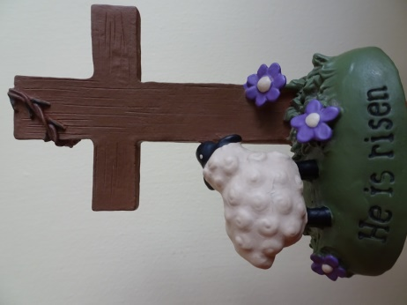
Remember …

Psalm 23 was “written by a shepherd,
who became a king,
because he wanted us to know about
a King who became a Shepherd.”

Max Lucado in Safe in the Shepherd’s Arms

